Get connected with your coach or program to access your performance testing results.
Download the Dashr Player Profile app from where you get your apps. Create an account, verify your email, and include as much information about yourself as you would like. You can use this app to track your results, enter local and national competitions, build a recruiting profile, and so much more.
Here are links to the Android and iOS app stores.
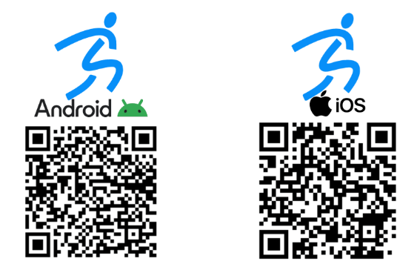
Once in the app, enter in the invite code below to register for this event.

INVITE CODE: __________________

Get out there and test!

